1. Print the numbers and character variables, we use the same cout object but without using quotation marks.

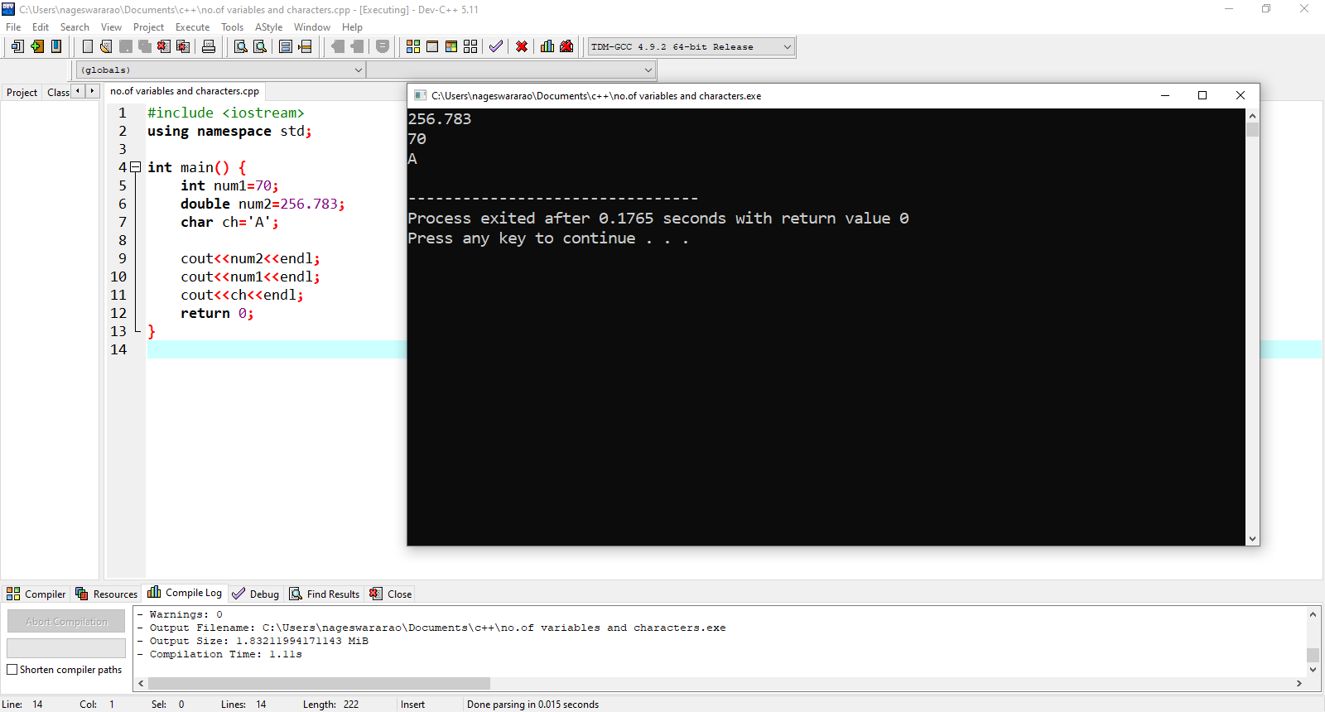

1. Print the numbers by taking input from keyboard using cin object.

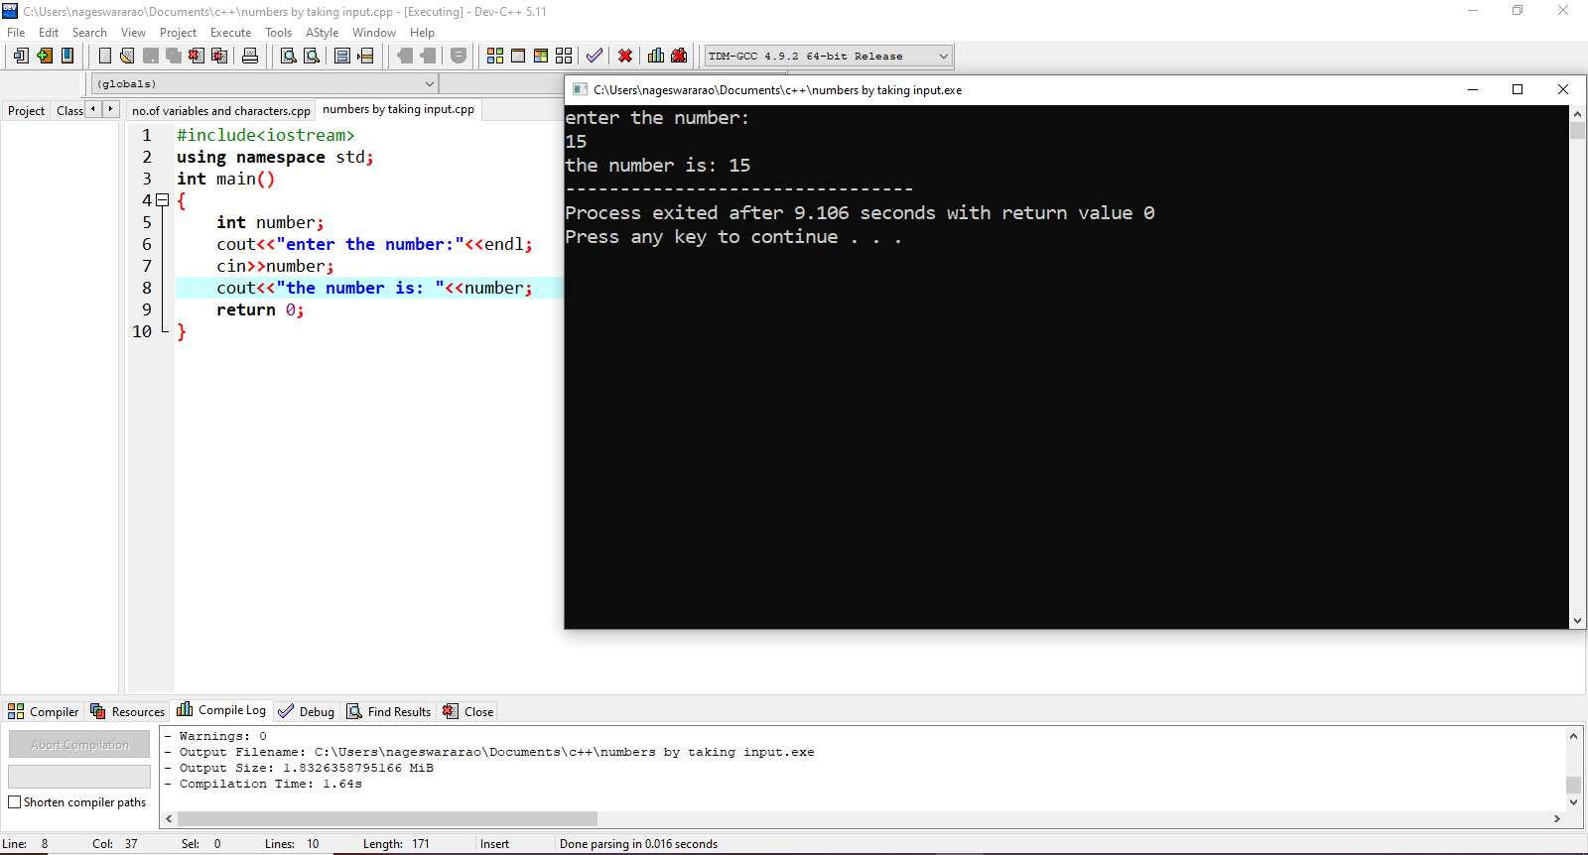

1. Write a program in c++ by taking multiple input from keyboard using cin object and cout object.

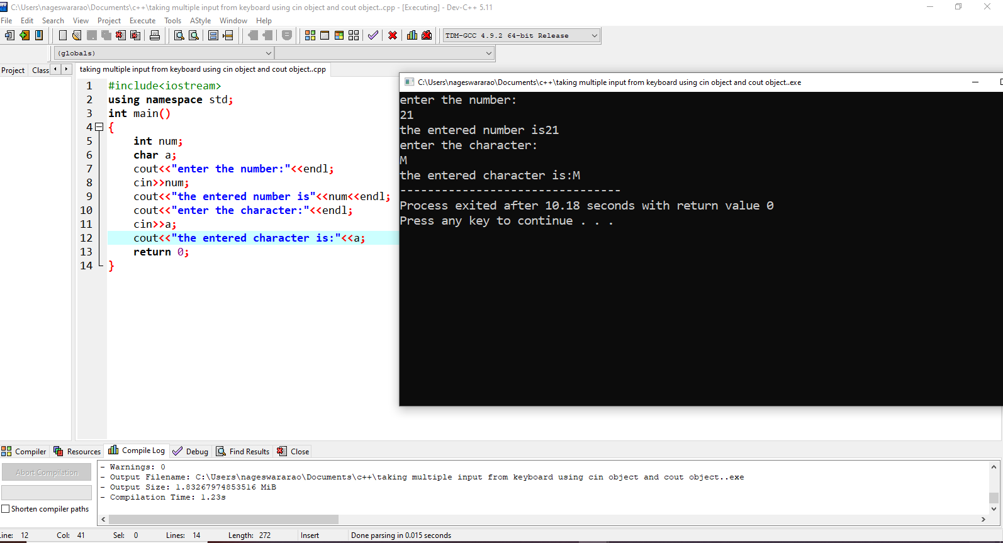

4. **Check if a number is even or odd.**

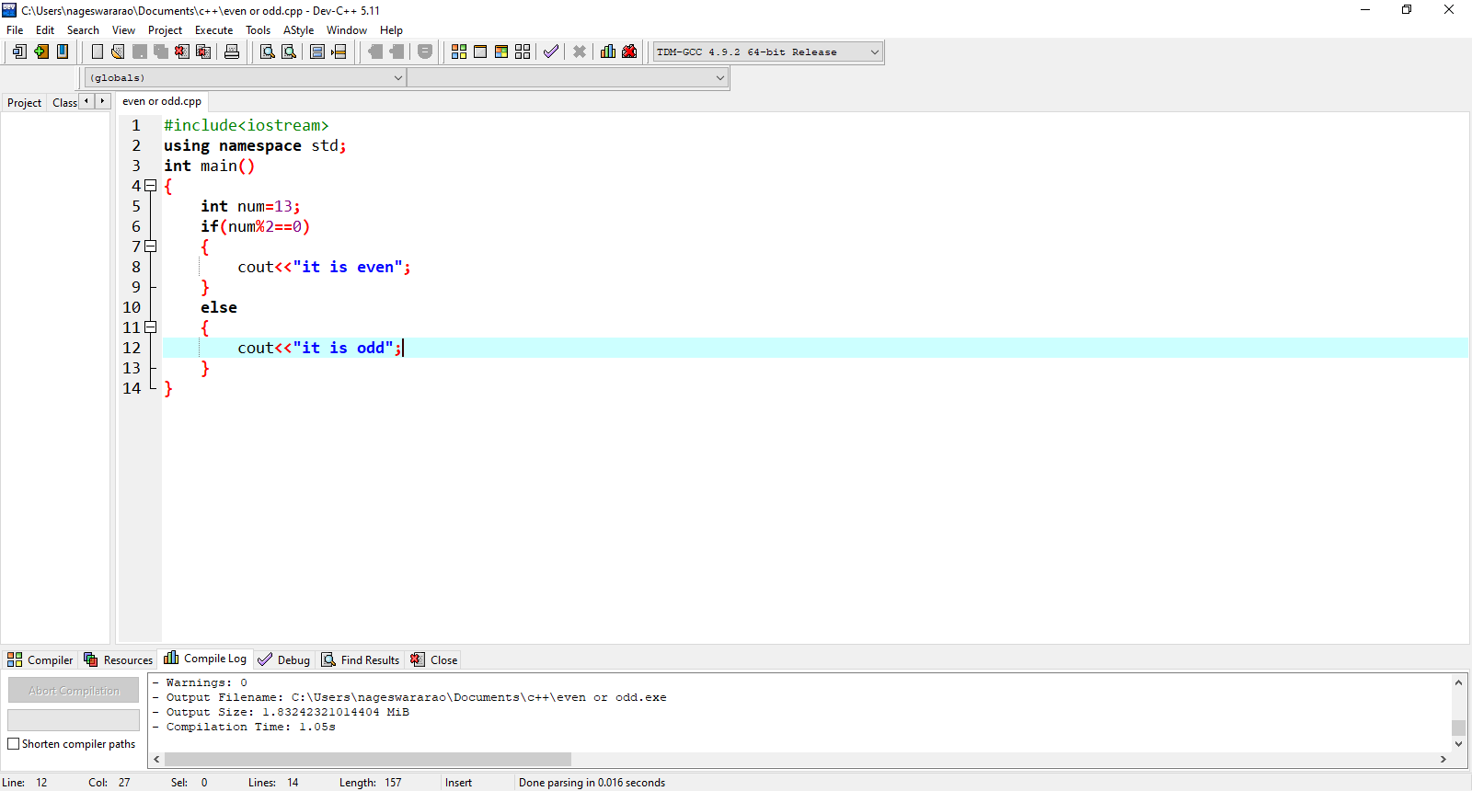

5.find error in this program  
#include  
#include  
Using namespace Std;  
int main();  
{  
int number;  
for(i=1; i<=6, i++)  
{  
cout<<"Value of variable i is: "<<number<<endl;  
getch();

}

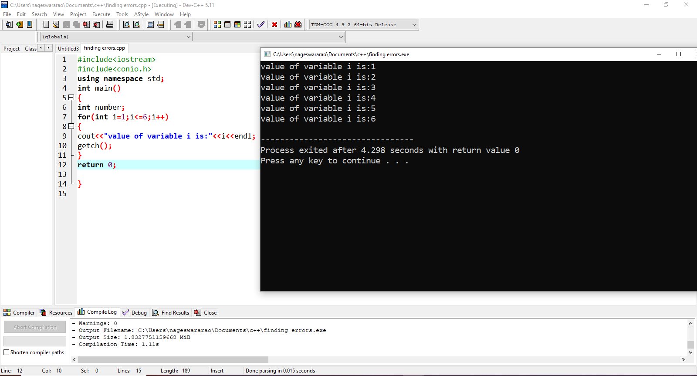

6. #include  
void main()  
{ int public=10;  
cout<public;  
}

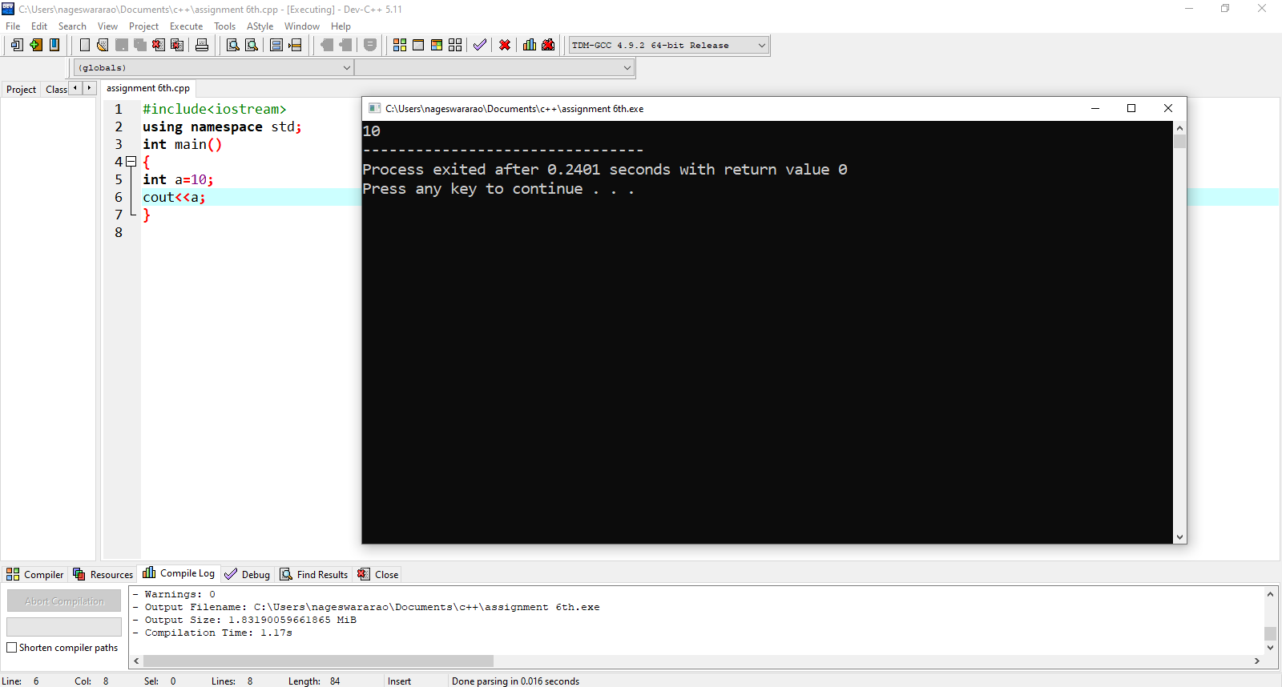

7.Write a c++ code for swapping of two numbers

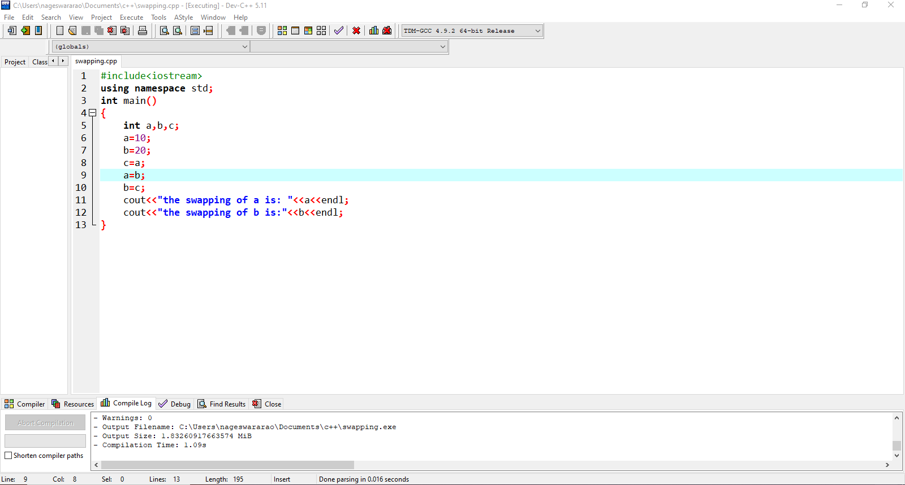

8.Wrapping data and its related functionality into a single entity is known as _____________  
a) Abstraction  
b) Encapsulation  
c) Polymorphism  
d) Modularity

9. What happens if the following program is executed in C and C++?

#include<stdio.h>

int main()

{

foo();

}

int foo()

{

printf("Hello");

return 0;

}

Error in both C and C++  
b) Warning in both C and C++  
c) Error in C++ but Warning in C  
d) Error in C but Warning in C++  
View Answer

Answer: c  
Explanation: In C++ all the functions should be declared before it is called otherwise the C++ compiler will give an error but in case of C the compiler just gives a warning and the program can be executed.

10. Write a C++ code to area of circle and area of rectangle.

